**SISTN WEBSTE ARCHITECTURE**



**EVENTS**

**CONTACT**

**MEMBERSHIP**

**ABOUT**

**HOME**

OFFICE ADDRESS

AND MAP OF LOCATION

**DROP DOWN MENU**

MEMBERSHIP CATEGORIES

MEMBERSHIP FORM

**DROP DOWN MENU**

WEBINARS

LECTURES AND SEMINARS

FOUNDERS DAY LECTURES

CONFERENCE

INDUCTION OF MEMBERS

**DROP DOWN MENU**

HISTORY

ORGANISATION

CONSTITUTION

MEMORANDUM OF ASSOCIATION

ARTICLE OF ASSOCIATION

WELCOME

**HOME PAGE**

**CONTENTS:**

Welcome to the Society for information Science and Technology of Nigeria (SISTN). SISTN is a nongovernmental organisation that is registered in Nigeria by the Corporate Affairs Commission (CAC) with a broad mandate to cater for the professional interests of information professionals and allied disciplines in Nigeria.

SISTN is committed to core professionalism in the information sciences such as information management, information systems, digital media and digital technologies, big data analytics, business analytics and business intelligence, machine learning and artificial intelligence to mention but a relevant few. Through our numerous programmes which runs throughout the year, we offer professional services to our members, non-members, corporate organisations in the public and private sector for the upgrade and augmentation of personnel skills and knowledge base. We collaborate with government institutions and the civil society in the delivery of our mandate.

If your stock in trade is digital marketing, social media and social network analysis, multimedia publishing, web technologies and library and science, we are equipped to cater for your professional needs. SISTN openly embraces professionals in the fields of bioinformatics, communication studies, geographical information systems, cyber and information security, data protection and privacy.

**Vision Statement: *A Nigerian society wherein quality information and appropriate information technologies are effectively harnessed to promote growth, development and social inclusion.***

**Mission Statement: *To advance knowledge and professionalism in information science and technology through research, education, and promotion of public awareness*.**

©SISTN 2024 All rights reserved.

**History**

**THE SOCIETY FOR INFORMATION SCIENCE AND TECHNOLOGY OF NIGERIA (SISTN): A BRIEF HISTORY**

The need for a Professional Society for trained and practicing information scientists and professionals in academia, public services, industries and allied disciplines as a platform to promote the growth and rapid development of the Information Science and Technology occupations, professions, and careers in Nigeria was keenly felt right from when the Africa Regional Centre for Information Science (ARCIS) began operation in 1990. However, several challenges and unforeseen circumstances prevented action on the formation of a professional body to cater to the needs of information professionals in Nigeria. ARCIS (now DDIS) has since trained more than 1,500 high-level human resources through its higher degree academic and professional degree programmes alone, not to talk of the exponentially growing number of graduates of bachelor’s and master’s degrees, higher national diplomas, and high-level industry certification programmes in the Information Science and Technology sector in Nigeria and in the diaspora.

The yearning for a professional body to cater to Nigerian graduates of the Information Sciences was realized on the 12th of April 2008 when Mr. Olatunji Apampa convened a meeting of like-minded individuals and professionals in the Information Sciences in Ibadan. In attendance at the meeting were Professor Mutawakilu Tiamiyu, Professor Oluwole Olatokun, Dr. Williams Nwagwu, Dr. Rosemary Agbonlahor, a host of ARCIS alumni, and many other attendees. Issues deliberated upon centred on the formation and registration of a professional body to cater specifically to the needs of professionals in the and decisions taken were as follows:

**Declaration and Name of Society**

The society shall be known as the “***Nigeria Society for Information Science and Technology”*** (NSIST, pronounced “en-cist” as suggested by Dr. Williams Nwagwu). April 12, 2008, was taken as the foundation day for NSIST.

**Vision Statement: *A Nigerian society wherein quality information and appropriate information technologies are effectively harnessed to promote growth, development and social inclusion.***

**Mission Statement: *To advance knowledge and professionalism in information science and technology through research, education, and promotion of public awareness*.**

The proposed professional body was eventually registered by the Corporate Affairs Commission of Nigeria (CAC) as the ***Society of Information Science and Technology of Nigeria (SISTN)*** with registration number ***CAC/IT/NO 74572*** on the 12th of January 2015.

**Objectives**

* To promote the education of information scientists and professionals
* To promote research in information science and technology
* To promote multidisciplinary collaboration and inter disciplinary approaches on issues pertaining to creation, sharing and use of information, knowledge and information technology for national and global development.
* To develop the competence and promote the professional integrity of information scientist and technologies.
* To champion and protect the interest of information science and technology profession and improve public awareness on matters pertaining to the practice of the profession.

SISTN seeks to promote the development of Information Science and Technology education and professional practice in Nigeria, as well as the career development and welfare of its members. SISTN is the culmination of more than five years of efforts by the ARCIS academic staff and alumni of ARCIS to initiate and develop a Professional Society whose membership comprises professionals from all subsectors and subfields of Information Science and Technology in Nigeria and around the world. SISTN was supposed to have formally been inaugurated at the 25-year anniversary of ARCIS in November 2015. However, this was not to be. SISTN is currently hosted by ARCIS online, and at its premises on Benue Road, in the University of Ibadan. ARCIS, as well as its staff and alumni serving as the pioneering SISTN officials, will be responsible for the promotion and development of SISTN in its first three years until SISTN is able to generate income to finance its operational activities and strategic projects.

It must be emphasised that the take off of SISTN was due to the efforts of many including the Department of Data and Information Science (DDIS formerly ARCIS). The contributions of individuals such as Professor M.A. Tiamiyu, Professor Oluwole Olatokun, Mr. Olatunji Apampa, Dr. Williams Nwagwu, Dr. Funmilayo Omotayo, Dr. Oladipupo Ajigboye and Dr. Rosemary Agbonlahor is acknowledged and appreciated always. The dedication to duty and love of the profession remains the driving force behind SISTN and its accolades of achievements.

©SISTN 2024 All rights reserved.

**ORGANIZATION AND CONSTITUTION**

**Governance**

The Constitution of SISTN provides for the following three governing and administrative organs to run its affairs:

**Board of Trustees (BOT)**

The Board of Trustees comprises the following people who sponsored the registration of SISTN with the Corporate Affairs Commission of Nigeria:

* Professor Mutawakilu Adisa Tiamiyu, Lecturer and Information Scientist
* Dr. Wole Michael Olatokun, Lecturer and Information Scientist
* Dr. Funmilola Omotayo, Lecturer and Information Scientist
* Mr. Olatunji Apampa, Researcher and Information Scientist

The main function of the Board of Trustees is to represent SISTN in all legal matters concerning the registration of SISTN with the Corporate Affairs Commission of Nigeria. The Board of Trustees shall also communicate to the Corporate Affairs Commission of Nigeria any changes in the constitution of SISTN as approved by its voting members.

**Governing Body (GB)**

The Governing Body is an organ established by the SISTN Constitution. Its members, as specified in the Constitution, comprises the following six statutory members, and not more than three other members co-opted from within and outside the information industry.

1. Chairman
2. Vice Chairman
3. General Secretary
4. Provost
5. Treasurer
6. Publicity Secretary

**Executive Committee (EXCO)**

The Executive Committee is an organ established by the SISTN Constitution. It is responsible for day to day administration of the affairs of the Society. It membership shall comprise the following:

1. Chairman
2. Vice Chairman
3. General Secretary
4. Provost (responsible for all academic and professional programmes, including conferences, meetings and professional training matters)
5. Treasurer (responsible for keeping and accounting for funds)
6. Business Secretary (responsible for income generation and marketing activities)
7. Publicity Secretary (responsible for managing all internal and external communications of the Society
8. Welfare Secretary (responsible for ensuring that members welfare needs are met by the Society’s programmes)

**Board of SISTN Fellows (BSF)**

The Board of SISTN Fellows (BSF) is a Committee of the Governing Body (GB) and shall assess and approve applications for admission to the SISTN Fellow membership. Its shall have as members all living SISTN Fellows, and the following four members of the Governing Body - Chairman, Vice Chairman, Secretary, Provost. The Secretary of the Governing Body shall be the secretary of the BSF. The Chairman of BSF shall be elected by a simple majority of members in a secret ballot. One-third of the membership of the BSF shall form quorum at its meetings if its membership is at least twelve (12), or four members if is membership is less than twelve (12).

**Application to Membership Assessment Committee (AMACOM)**

This is a sub-committee of the Executive Committee which shall be responsible for receiving and assessing all application to SISTN membership categories below that of SISTN Fellow. It membership shall comprise the following members of the Executive Committee: Vice Chairman, Provost, Business Secretary, Publicity Secretary, Welfare Secretary.

SISTN Constitution: (hyperlink to constitution in PDF should be placed here)

©SISTN 2024 All rights reserved

**MEMBERSHIP**

**SISTN Membership Categories**

**Professional Member**

A person, who may not have been previously a Student Member of SISTN, may apply for admission to the Professional Member grade of SISTN provided he/she had obtained a tertiary-level qualification relevant to occupation or professional practice in any aspect of the Information Science and Technology industry. The industry is defined for this purpose to include (alphabetically): Archives Studies/Management, Communication Arts/Science, Computer Science, Information Management, Information Science, Information Services, Information Systems, Information Technology, Innovation Management, Library Management, Library Science, Media Science, Media Studies, Records Management, Research and Development Management, Telecommunications, and other related fields, occupations and professions. Tertiary-level educational qualification is defined for this purpose to include bachelor’s, master’s and doctoral degrees, higher and ordinary national diplomas, national certificates of education, professional information industry certificates endorsed by SISTN, and equivalent qualifications. Professional Members vote on general Society business, may hold office or committee chairmanships, may sit on committees and vote on committee matters. Professional Members are entitled to use the letters PSISTN (Professional Member of the Society for Information Science and Technology of Nigeria) after their names. Associate Members receive all publications of SISTN, and are not exempt from participation fees in any SISTN activity.

**Associate Member**  
A Professional Member of SISTN may apply for upgrade of their membership status to Associate Member provided he/she has accumulated not less than ten years experience in Information Science and Technology occupations or professional practice since attaining the qualifications that qualifies him/her for Professional Member grade, and has been Professional Member of SISTN for at least 5 years immediately preceding the date of the application for upgrade. Associate Members vote on general Society business, may hold office or committee chairmanships, may sit on committees and vote on committee matters. Associate Members are entitled to use the letters ASISTN (Associate of the Society for Information Science and Technology of Nigeria) after their names. Associate Members receive all publications of SISTN, and are not exempt from participation fees in any SISTN activity.

**Corporate Membership**

Corporate organisations that are in the information business have a right to apply for the status of corporate member provided that they fulfil all of the requirements.

**Student Member**  
Student Members are currently in formal, full-time training programs in tertiary educational institutions in or in Professional Certification Programmes in the field of Information Science and Technology recognized by SISTN and have an interest in the work of SISTN. Student members receive copies of e-magazines and e-newsletters of SISTN, reduced registration fees for SISTN meetings and discounted subscription rates for the SISTN journals. Student Members are required to upgrade to the appropriate Active Membership category one year post-training completion. Student Members do not hold office or vote. An applicant for Student member must provide letter of attestation of the applicant’s status written on the headed paper of the relevant tertiary institution, and the institution shall be contacted to validate the letter, which must contain the following information: name of applicant, institution and program/department name, date of program completion, contact name and address of sponsor, attestation.

**Fellows**

The SISTN Fellow membership grade is given to a person in recognition of his/her lifetime professional or supportive contribution to the development of the Information Science and Technology professions, industry or occupations in Nigeria and any other African country. A Professional Member or Associate Member may apply for upgrade of membership status to SISTN Fellow, provided he/she has attained the age of 45 years, been active in the information industry and related sectors for at least 15 years, and been Professional Member or Associate Member for at least 5 years. Also, other persons who may not satisfy the above conditions may be recommended for admission to SISTN Fellow membership by the SISTN Executive to the SISTN Council. The SISTN Council approves and admits all SISTN Fellows. Fellows do not vote on general Society business, do not hold office or committee chairmanships, but may sit on committees and vote on committee matters. Fellows are entitled to use the letters FSISTN (Fellow of the Society for Information Science and Technology of Nigeria) after their names. Fellows receive all publications of SISTN, and are exempt from participation fees in any SISTN activity.

**Honourary Fellowship**

The SISTN Honourary Fellowship is bestowed to a person in honorary recognition of his/her lifetime professional or supportive contribution to the development of the Information Science and Technology professions, industry or occupations in Nigeria and any other African country. A Professional Member or Associate Member may apply for upgrade of membership status to SISTN Fellow, provided he/she has attained the age of 55 years, been active in the information industry and related sectors for at least 20years. Also, other persons who may not satisfy the above conditions may be recommended for admission to SISTN Fellow membership by the SISTN Executive to the SISTN Council. The SISTN Council approves and admits all SISTN Fellows.

**Membership Application Form**: (hyperlink to SISTN membership application form)

©SISTN 2024 All rights reserved

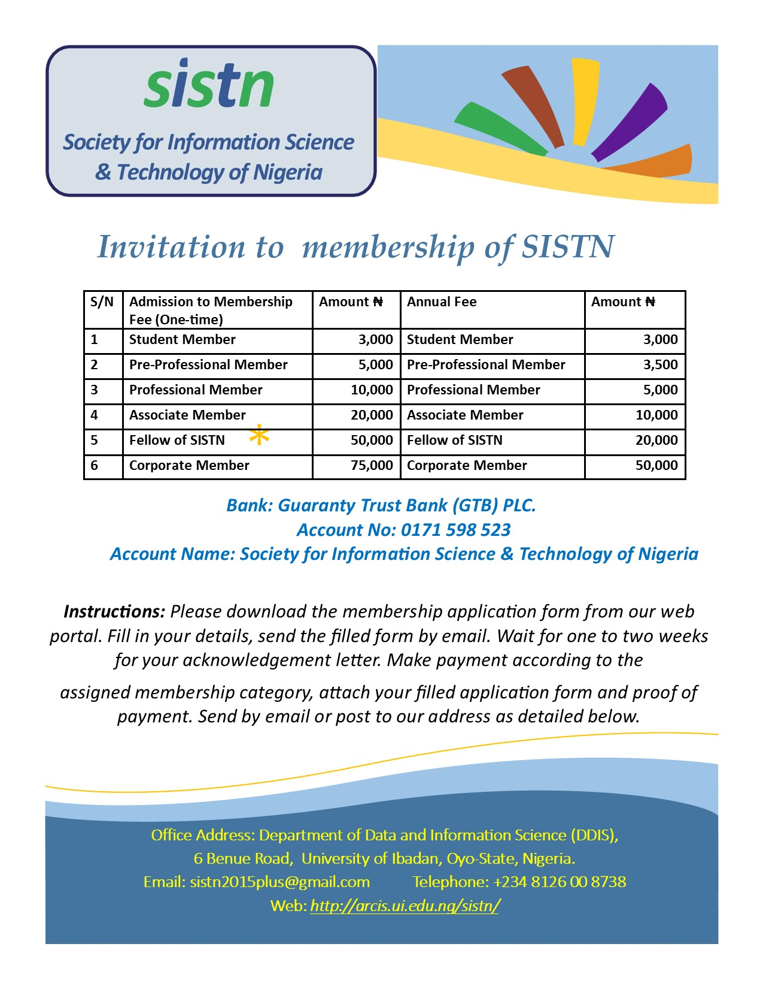

©SISTN 2024 All rights reserved

**EVENTS**

**SISTN Webinars**

SISTN holds its webinars at regular intervals. Seasoned professionals in the information sciences and technology speak and discuss topics and based on contemporary issues and in the field. Participants at our webinars are encouraged to ask questions and make submissions based on the topic under consideration.

**Seminars and Workshops**

SISTN holds regular seminars, workshops and training programmes ar different locations in Nigeria.

**Founders Day Lecture**

In April of every year, SISTN hosts professionals in the information industry to its annual Founders Day Lectures. The lectures are designed to commemorate the founding of SISTN on April 12, 2008. Corporate organisations have an opportunities to showcase their products at the event. Startups are particularly encouraged to register their presence at the event.

**Annual Conference and Induction of Members**

The SISTN Conference and induction ceremony holds annually as announced by the organisation. Induction ceremony is primarily to welcome new members into the SISTN family. While the conference which lasts for between three for days was designed to foster unity, professionalism and development of the profession amongst members and other interested parties.

©SISTN 2024 All rights reserved.

**CONTACT**

**Office Address**: Department of Data and Information Science, 6 Benue Road, University of Ibadan, Ibadan, Oyo State, Nigeria.

For membership enquiries, please send your email to: [*sistn2015plus@gmail.com*](mailto:sistn2015plus@gmail.com)

For seminar and webinar enquiries: [*sistninfo@gmail.com*](mailto:sistninfo@gmail.com)

**Website**: [*www.sistn.org.ng/www.sistn.net*](http://www.sistn.org.ng/www.sistn.net)

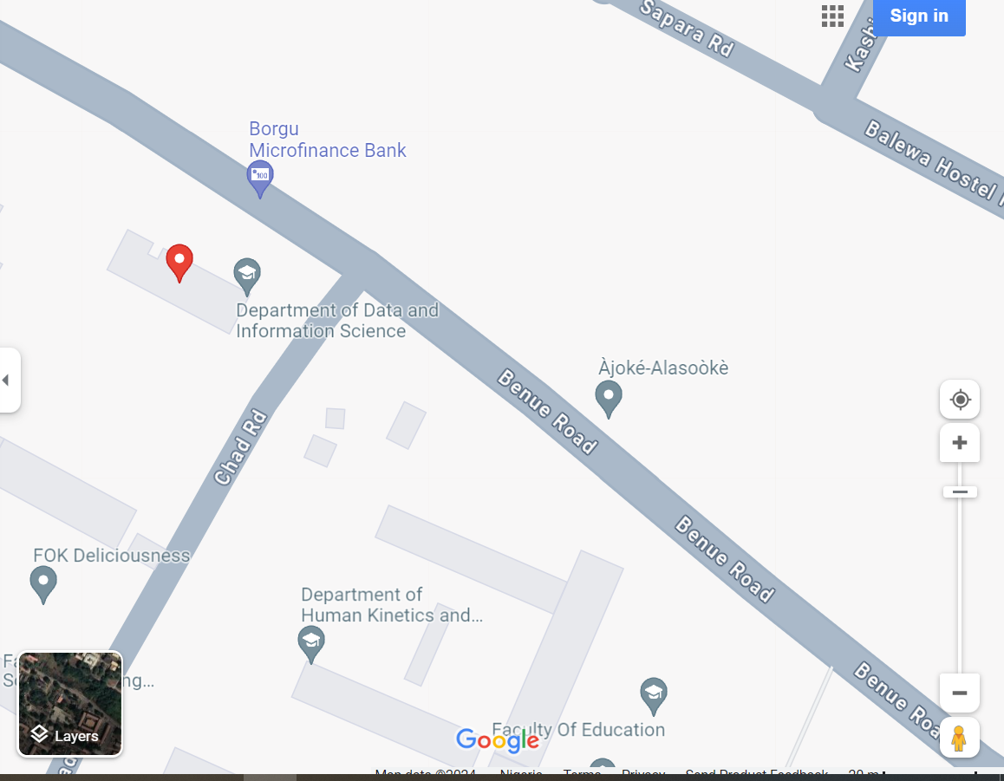

**Locate us via Google Maps**

©SISTN 2024 All rights reserved.